**[31] Design PDA For Input AnBn**

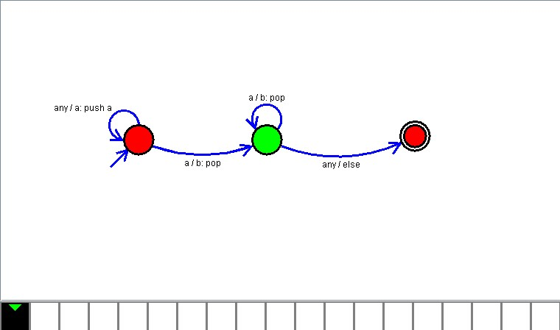

**Result**

The PDA is designed to compute the given strings as input using Simulator